No need of AdBlocker Extension, you can create one

Hello all, we will make it possible by adding the website name to our hosts file with “0.0.0.0”.

**Pre-request:**

1. What the hosts file.
2. Where you can find the hosts file.

* What's the Hosts file

The Hosts file is used by the operating system to map human-friendly hostnames to numerical Internet Protocol (IP) addresses which identify and locate a host in an IP network. The hosts file is one of several system resources that address network nodes in a computer network and is a common part of an operating system's IP implementation.  
  
The Hosts file contains lines of text consisting of an IP address in the first text field followed by one or more host names. Each field is separated by white space (Tabs are often preferred for historical reasons, but spaces are also used). Comment lines may be included, and they are indicated by a hash character (#) in the first position of such lines. Entirely blank lines in the file are ignored.

If the Hosts file is changed from default, resetting it can help resolve some connectivity issues.

* Where you can find the host’s file.

**For Windows:** File Location: c:\Windows\System32\Drivers\etc\hosts

**For Linux:** File Location: /etc/hosts

**How to Block the specific website:**

1. Navigate to the host’s file.

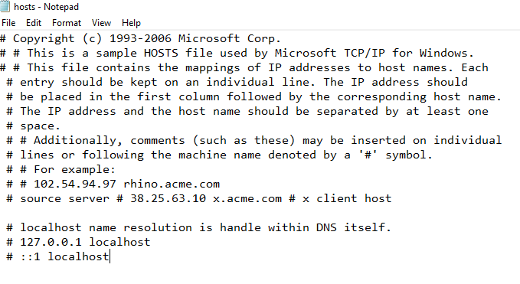

1. Add the website name with the prefix 0.0.0.0

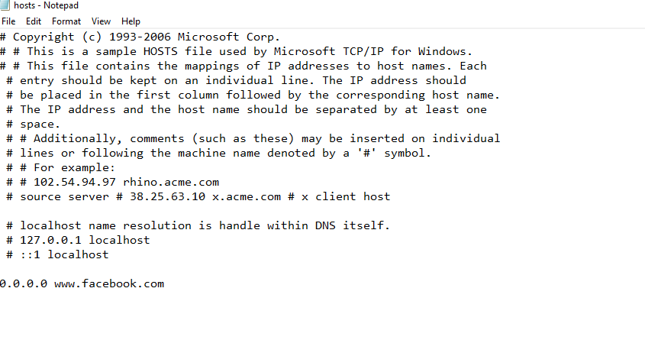

1. Save it, and to verify it open any browser and launch that site.
2. We can’t add many Ad. Or fake websites manually, so there is a Github link, which contains fake/Ad websites.

**Link**: <https://github.com/StevenBlack/hosts>

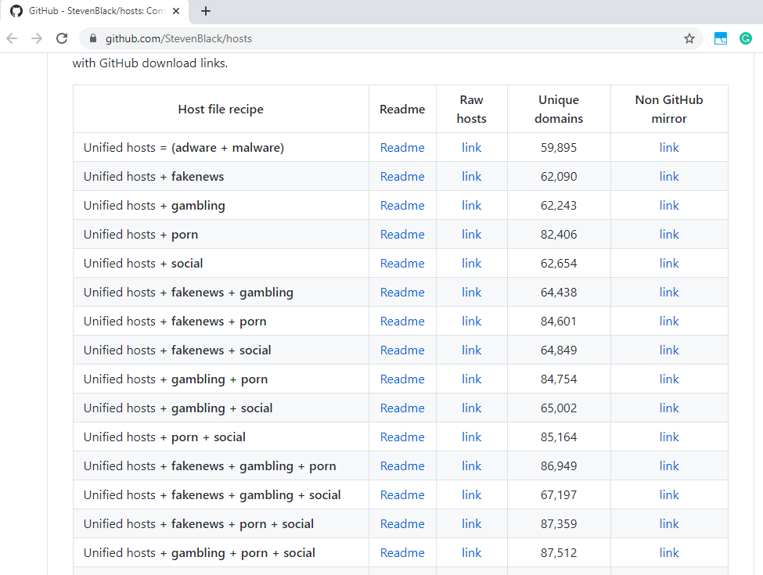

1. Open the link, copy it and paste it in the hosts file.

Thank you,

Zan